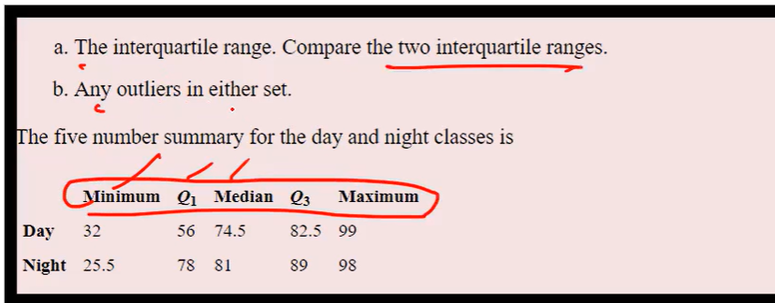

**DAY**

**Lower bound : Upper bound :**

=Q1 – 1.5(IQR) = Q3+1.5(IQR)

= Q1 – 1.5(Q3-Q1) = Q3 + 1.5(Q3-Q1)

= 56 – 1.5(82.5-56) = 82.5 + 1.5(82.5-56)

= 56 – 1.5(26.5) = 82.5 +1.5(26.5)

= 56 – 39.75 = 82.5 + 39.75

**= 16.25 = 122.25**

**Lower bound for day : 16.25**

**Upper bound for day: 122.25**

**OUTLIERS :**

* No outliers for lower bound as there is no value less than the lower bound value **16.25.** Min value for the class is **32**
* No outliers for upper bound as there is no value higher than the upper bound value **122.25.** Max value for the class is **99**

**NIGHT:**

**Lower Bound: Upper Bound:**

**=** Q1 – 1.5(IQR) = Q3 + 1.5(IQR)

= Q1 – 1.5(Q3-Q1) = Q3 + 1.5(Q3-Q1)

= 78 – 1.5(89-78) = 89 + 1.5(89-78)

= 78 – 1.5(11) = 89 + 1.5(11)

= 78 – 16.5 = 89+16.5

= 61.5 = 105.5

**Lower bound for night: 61.5**

**Upper bound for night: 105.5**

**OUTLIERS :**

* No outliers for lower bound as there is no value less than the lower bound value **61.5.** Min value for the class is **25.5**
* No outliers for upper bound, as there is no value higher than the upper bound value **105.5.** Max value for the class is **98**